**Frontend Development with React.js**

**Project Documentation format**

**Project Title**: [Cryptoverse:A cryptocurrency DashBoard]

**Team Number**:SWTID1741166477156881

**Team Members**:

|  |  |  |
| --- | --- | --- |
| **Roles** | **Team Member** | **Email ID** |
| **Team Leader** | **Malini V** | **malinivijayakumar11@gmail.com** |
| **Team Member 1** | **Manisha G** | **manisha.280415@gmail.com** |
| **Team Member 2** | **Rubini A** | **Rubysaranya2@gmail.com** |
| **Team Member 3** | **Swetha S** | **Swetha9990b@gmail.com** |

1.Introduction

* Welcome to Cryptoverse, the ultimate cryptocurrency dashboard designed to bring you closer to the dynamic world of digital currencies. Whether you're an experienced trader or just stepping into the world of crypto, Cryptoverse provides all the tools you need to track, analyze, and manage your investments seamlessly.

### 2. Project Overview

**Purpose**: This project is a **responsive cryptocurrency tracking web application** that provides users with real-time updates, market statistics, and news related to cryptocurrencies.

**Features**: The application features a well-structured layout with a sidebar navigation menu, interactive charts, and detailed information on various digital assets.

**3**. Objectives

* Provide **real -time and historical** cryptocurrency market data.
* Deliver **data-driven insights** through charts and analytics.
* Aggregate **crypto-related news** for informed decision-making.
* Ensure a **seamless user experience** across all devices.
* Offer a **secure and scalable platform** for future enhancements.
* Enable **customization and user preferences** for personalized dashboards.
* Crypto Focus is a responsive and user-friendly cryptocurrency analytics platform that aggregates data from multiple sources to provide a comprehensive view of the digital asset market. It features real-time price tracking, historical data visualization, crypto-related news, and insights on various coins and tokens. Users can explore in-depth statistics, compare cryptocurrencies, and stay updated with the latest trends.
* The platform is built with modern web technologies, ensuring high performance and scalability. Its modular structure allows for easy integration of additional features and external APIs.

### 4. Architecture

**1. Frontend:**

* **Framework:** React.js (or Vue.js) for dynamic UI update
* **Styling:** CSS (SCSS) with responsive design for all screen sizes
* **State Management:** Redux (or Context API) for efficient
* **Data Visualization:** Chart.js or D3.js for historical data representation
* **Authentication:** Firebase or OAuth for user authentication

**2. Backend:**

* **Technology:** Node.js with Express.js for API handling
* **Database:** MongoDB (NoSQL) or PostgreSQL (SQL) for storing user preferences, historical data, and analytics
* **Data Sources:** Integration with external APIs like CoinGecko, CoinMarketCap, or Binance API for live cryptocurrency data
* **Caching:** Redis for optimizing API response times
* **Security:** JWT for secure authentication, HTTPS encryption, and rate limiting

### ****3.**** Hosting & Deployment:

* **Frontend Hosting:** Vercel or Netlify
* **Backend Hosting:** AWS, DigitalOcean, or Heroku
* **Database Hosting:** MongoDB Atlas (for MongoDB) or AWS RDS (for PostgreSQL)

### 5. Setup Instructions

**Prerequisites**: **Install Node.js** (if using React, Angular, or any JS framework

Install a **package manager (npm/yarn)**

### 

### Installation:

sh

Copy code

npm install

### 6. Folder Structure :

* **public/**: Contains assets and the main HTML file which is used as the base for your app. It's static content that the browser directly accesses.
* **src/**: The main source code of your app. This includes all your React components, pages, and other logic.
* **assets/**: Static files like images, fonts, or anything used across the app.
* **components/**: Reusable UI components that you can include on different pages (Navbar, Footer, etc.).
* **pages/**: Each page of your app can be in a separate file (Home, CoinDetail, News, etc.).
* **styles/**: Stylesheets or CSS-in-JS files that manage the appearance of your app.
* **utils/**: Helper functions that can be reused across your app (like fetching data from an API or formatting numbers).
* **config/**: Stores configurations, like API endpoints, environment settings, or constants.
* **env**: Holds sensitive environment variables like API keys, URLs, or authentication tokens.
* **package.json**: Contains metadata about your app, including dependencies, scripts, and configurations for the package manager (npm or yarn).
* **README.md**: Documentation for anyone who is working on or using the project.

This is just one of many ways to organize the structure depending on your project’s needs. Do you have specific requirements for your project that need to be reflected in this structure?

### 7. Running the Application

• Start the development server:

sh

Copy code

npm start

• Open the browser and visit:

arduino

Copy code

http://localhost:3000

### 8. Component Documentation

## **Navbar Component**

* Purpose:
* The Navbar provides navigation between the main sections of the Cryptoverse application.
* Features:
* **Logo**: Displays the app's logo linked to the home page.
* **Menu**: A list of links to different sections of the app (e.g., Home, Coin Details, News).
* **Responsive Design**: The menu adapts to different screen sizes using media queries.
* **Interactive Menu Control**: A collapsible menu on mobile for better usability.
* Key Styles:
* **Background Color**: A dark blue (rgb(41, 0, 249)) for the navbar background.
* **Text Color**: White text for menu items.
* **Hover Effects**: Links turn to a pink color (var(--pink)) on hover.
* html
* Copy
* <div class="navbar">
* <div class="logo-container">
* <a href="/" class="logo">Cryptoverse</a>
* </div>
* <ul class="menu">
* <li class="menu-item"><a href="#" class="link">Home</a></li>
* <li class="menu-item"><a href="#" class="link">Coins</a></li>
* <li class="menu-item"><a href="#" class="link">News</a></li>
* </ul>
* </div>
* **Coin Detail Container**
* Purpose:
* Displays detailed information about a selected cryptocurrency.
* Features:
* **Heading**: Displays the name of the coin and additional info.
* **Stats Container**: Shows various statistics such as market cap, price, volume, etc.
* **Links to external resources**: Provides links to the coin's official websites and other relevant resources.
* Key Styles:
* **Coin Name**: Large and bold in pink to stand out.
* **Stat Names**: Each stat is styled with bold text for emphasis.
* **Responsive Layout**: Layout adapts with multiple columns on desktop, single column on mobile.
* html
* Copy
* <div class="coin-detail-container">
* <div class="coin-heading-container">
* <h2 class="coin-name">Bitcoin (BTC)</h2>
* <p>Current Price: $45,000</p>
* </div>
* <div class="stats-container">
* <div><h2>Market Cap</h2><p>$850B</p></div>
* <div><h2>24h Change</h2><p>+3.5%</p></div>
* </div>
* <div class="coin-desc-link">
* <a href="https://bitcoin.org" target="_blank">Official Website</a>
* <a href="https://www.coingecko.com/en/coins/bitcoin" target="_blank">CoinGecko</a>
* </div>
* </div>
* **Coin Stats Component**
* Purpose:
* Displays individual cryptocurrency stats (like price change, market cap, volume) in a structured format.
* Features:
* **Responsive Design**: Information adapts to screen size.
* **Hover Effects**: Stats items change background color on hover.
* Key Styles:
* **Container**: Flexbox for responsive layout.
* **Stat Background**: Slight gray background with hover effects in var(--bgSecondary).
* html
* Copy
* <div class="coin-stats">
* <div class="coin-stats-name">
* <p>Price</p>
* <p class="stats">$45,000</p>
* </div>
* <div class="coin-stats-name">
* <p>Market Cap</p>
* <p class="stats">$850B</p>
* </div>
* </div>
* **News Card Component**
* Purpose:
* Displays news articles related to cryptocurrencies.
* Features:
* **Title & Content**: Shows news headline with brief content.
* **Image**: Displays a thumbnail image for the article.
* **Provider Name**: The source or publisher of the news.
* Key Styles:
* **Flexbox Layout**: For image and text alignment.
* **Card Hover**: Background color changes on hover for interactivity.
* html
* Copy
* <div class="news-card">
* <div class="news-image-container">
* <img src="image.jpg" alt="news thumbnail" class="img">
* <div class="news-title">
* <h3>Bitcoin Hits New All-Time High</h3>
* <p>Bitcoin has reached a new record high... </p>
* </div>
* </div>
* <div class="provider-container">
* <span class="provider-name">CoinTelegraph</span>
* </div>
* </div>
* **Footer Component**
* Purpose:
* The Footer section contains links and basic information about the app and its developers.
* Features:
* **Social Media Links**: Direct links to Twitter, Discord, etc.
* **Copyright Information**: Displays app ownership.
* Key Styles:
* **Background**: Black background with white text for contrast.
* **Centered Content**: Uses flexbox to center the content.
* html
* Copy
* <footer class="footer">
* <div class="footer-heading">Cryptoverse</div>
* <div>© 2025 All Rights Reserved</div>
* <div>
* <a href="https://twitter.com" class="link">Twitter</a>
* <a href="https://discord.com" class="link">Discord</a>
* </div>
* </footer>
* **Chart Header Component**
* Purpose:
* Displays the title and price chart for a specific cryptocurrency.
* Features:
* **Title**: The name of the coin along with the chart title.
* **Price Section**: Displays the current price and price change over time.
* Key Styles:
* **Chart Title**: Bold and prominent, with a specific color scheme (rgb(27, 3, 73)).
* **Price Container**: Flexbox to organize price data and changes.
* html
* Copy
* <div class="chart-header">
* <h2 class="chart-title">Bitcoin Price Chart</h2>
* <div class="price-container">
* <p class="current-price">$45,000</p>
* <p class="price-change">+3.5%</p>
* </div>
* </div>

### 9. Testing

You can create a simple test section in your HTML file and apply some of the styles to see if they render properly. For example:

html

Copy

<div class="test-section">

<h2 class="coin-name">Test Coin Name</h2>

<p class="coin-stats">Market Cap: $1,000,000</p>

<a href="#" class="link">Click Here</a>

</div>

**2. Apply Inline Styles for Debugging**

Modify some elements temporarily with inline styles to check if the CSS is properly linked:

html

Copy

<p style="color: var(--pink); font-size: 18px;">Testing CSS Variables</p>

**3. Use Browser Developer Tools**

* Open your web page in a browser.
* Right-click and select **Inspect** (or press **F12**).
* Check if the styles are being applied in the **Elements** tab.
* Look for any errors in the **Console** tab.

**4. Add a Temporary Background**

To ensure styles are applied to specific sections:

css

Copy

.test-section {

background-color: red;

padding: 20px;

color: white;

}

Then add <div class="test-section">Testing Background</div> to your HTML.

**5. Check Media Queries**

Reduce your browser window size to ensure that the media queries, such as those for max-width: 1000px and max-width: 500px, are working correctly.

Would you like help with debugging a specific issue in your CSS?

### 10. Screenshots or Demo

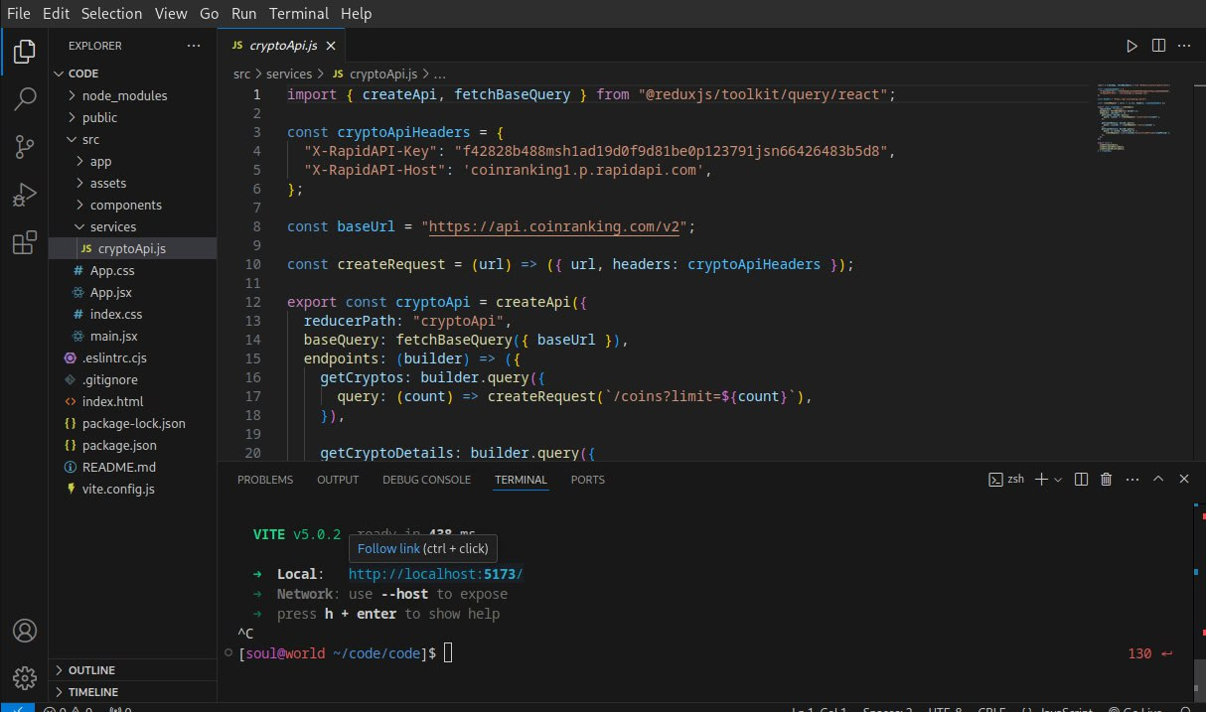



1. Known Issues Incorrect Variable Declaration in CSS:

The following line in :root is incorrect:

css

Copy

--bgPrimary: #fff bg secondary: #0a5800;

Fix:

css

Copy

--bgPrimary: #fff;

--bgSecondary: #0a5800;

**Mobile Responsiveness Issues:**

* 1. The menu position is set **absolutely**, which may cause overlap.
  2. Fix: Adjust breakpoints in media queries.

**Hardcoded Colors in Some Classes:**

* 1. background-color: rgb(41, 0, 249); should use a variable instead.

### Future Enhancements

* Dark Mode Toggle
* User Authentication & Profile Management
* Live Cryptocurrency Trading Data Integration
* Customizable Themes & Layouts

* Performance Optimization (Lazy Loading, Code Splitting)

**13.** Conclusion

**1.. Crypto Insights & Analytics**

Interactive charts for price trends and comparisons

Technical indicators for trading analysis

**2. News & Updates**

Aggregated cryptocurrency news from multiple sources

Breaking news notifications

**3 . Crypto Comparisons**

Side-by-side comparison of cryptocurrencies

Market performance insights

**4.User Dashboard (Optional for Registered Users)**

Personalized watchlist

Portfolio tracking and alerts

**5.Security & Performance Enhancements**

Secure user authentication

Optimized performance with API caching